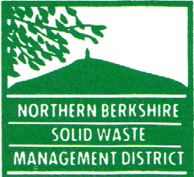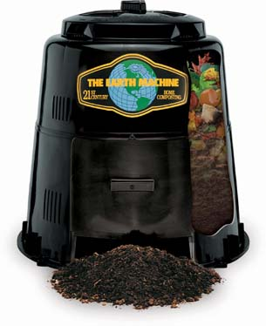
PRE-ORDER YOUR HOME COMPOSTING BIN
Contact Linda Cernik, Program Coordinator 413-743-8208, or email lcernik@nbswmd.com
Open to all member town’s
Distribution day; Saturday, March 26th, 2022; 9am to noon, Town of Cheshire Transfer Station
6 Main Street, Cheshire, MA 01225
Earth Machine, 80-gallon Home Compost Bin~ 2022 Composting is a great way to recycle our organic “waste” into a beneficial soil amendment for our yards and gardens. Composting at home can also help reduce methane production at landfills. Using the compost in our landscapes helps store carbon in the soil instead of releasing it to the atmosphere. Home composting by composting leaves, grass clippings, garden debris, fruit peels, vegetable scraps, tea bags, coffee grounds, eggshells, paper towels, napkins and even paper bags. It is easy to make compost, and the Members Towns makes it even easier by offering rodent-resistant home composting bins for $25, over 50% off the retail price. Made possible with MassDEP Sustainable Materials Recovery program contribution by each member town. Payment check or cash, Debit / credit cards not accepted. Checks made payable to Northern Berkshire Solid Waste (NBSWMD). Limited Supply.

